MAKE HAMILTON GREAT AGAIN



#HEXIT

Read further to see how the Republic of Hamilton will truly be the city and now country of the future!

OUR VISION

5 STEP PLAN

1. Build a **fence** around Hamilton and surrounding regions (there will be a gate!)
2. Open Sign Ups
3. Establish utilities
4. Re-route roads and highways to accommodate fence
5. Elect democratic leader of Hamilton (David Bennett)

Hamiltron, Kirikiriroa, the City of the Future! For the longest time, we’ve been held back by the rest of New Zealand. That time is over. The future is now. The future is Hexit.

Our vision for 2020 is a strong, independent Hamilton. No longer tied down by the rest of New Zealand, we'll create a better life for Hamiltonians; free from cruel jokes at our expense, and always being Shit Town of the Week.

We're going to build a fence. 1.8 metres tall, number 8-wire clad, high-quality Hamilton timber, processed freshly from our bordering friends at Tokoroa. It'll encompass our great lands; from the Raglan waters to eastern Hobbiton.

No longer can Aucklanders steal our reasonably-priced homes, or claim they “knew Hamilton was cool all along”. Hamilton has always been cool.

Support us. Support **Hexit**.

* **Jesse Mulligan**



#BUILDTHATFENCE

* Our boundary will include our new capital Hamilton plus a selected surrounding area and will exclude Huntly and Matamata but retain their valuable resources of the power station and Hobbiton respectively.
* The materials will be locally sourced timber with the famous Kiwi number 8 wire perched on top.
* Down to business, there will be a cost. Luckily we have acquired a professional quote from Chad at Mitre 10 and the mighty 1.8M fence will only cost us $6 Million. And will adhere to the 1978 fence regulation.
* Making jobs! Hamiltonians will build the fence with opportunities for local businesses, including Chad from Mitre 10!

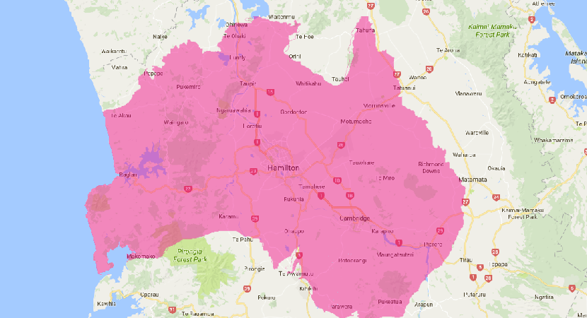

Hamilton

The economic Rundown

**Raglan**

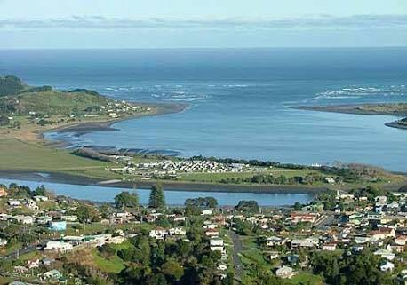

**Port** - To promote exports of goods and services, we will need access to a port for ships and freight

**Windmills** - To harness energy from natural sources and reduce the carbon footprint from reliance on fossil fuels. We will utilize the wind power farm to reduce energy costs and make Hamilton and the fenced region more self-sufficient

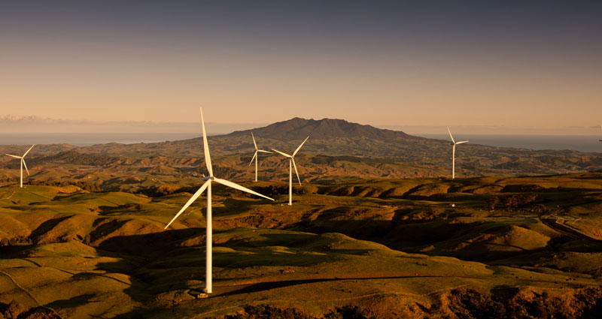

**Zero waste** - As part of our sustainable outlook, we want to promote zero waste. Reduce, reuse and recycle! We want to ensure minimal pollution

**Huntly**

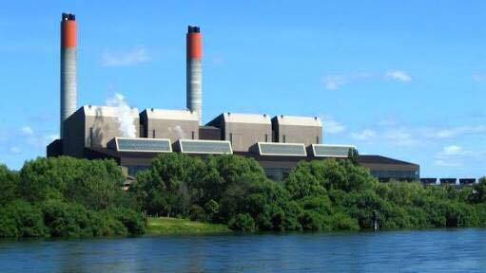

**Power station** - will be included within the borders of the Hamilton-Waikato region. Excess power will be sold off to neighbouring districts, including Auckland (at a cost, of course. There are no free lunches!)

**Tourism**

**Hobbiton** - As one of the central tourism hubs in New Zealand and home of Peter Jackson’s Lord of The Rings, we plan on using Hobbiton to increase Hamilton’s tourism and GDP. Subsequent remakes or or future developments will benefit us!

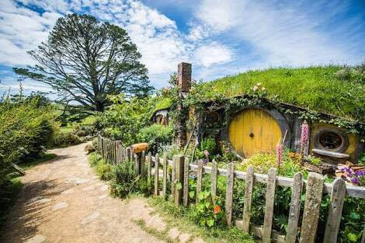

**Waikato Hospital** - The capacity is above our new found population and therefore Aucklanders can pay a premium to use our top grade facility

**Auckland**

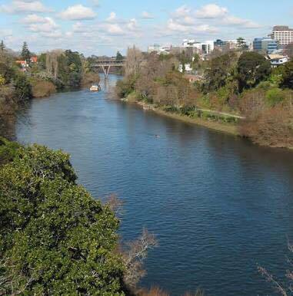

**Water supply** **to Auckland** - during drought up to 30% of Auckland’s water is supplied by the Waikato River

The economic Rundown

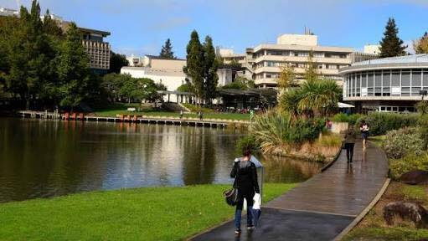

**Education**

**University of Waikato** - Proudly ranked 338th in the world according to QS World University Rankings in 2015

**Air Travel**

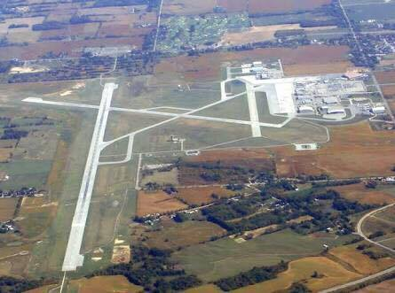

**Hamilton International Airport** - already has the infrastructure for international flights. We will improve this to remove the need to travel to Auckland for holiday-going

#Spotlight

**Employment**

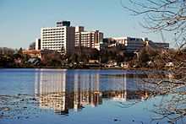

Hamilton is a fast growing urban area with several employment opportunities. It is the hub for the agricultural and dairy industries in New Zealand, and the technology industry is emerging as well. Hamilton is home to the University of Waikato and Waikato Hospital, which are large employers of people with diverse backgrounds. Whether it’s education, research, medicine or other occupations, there is something for all Hamiltonians. The construction of the fence and other new infrastructure will also increase the number of job opportunities

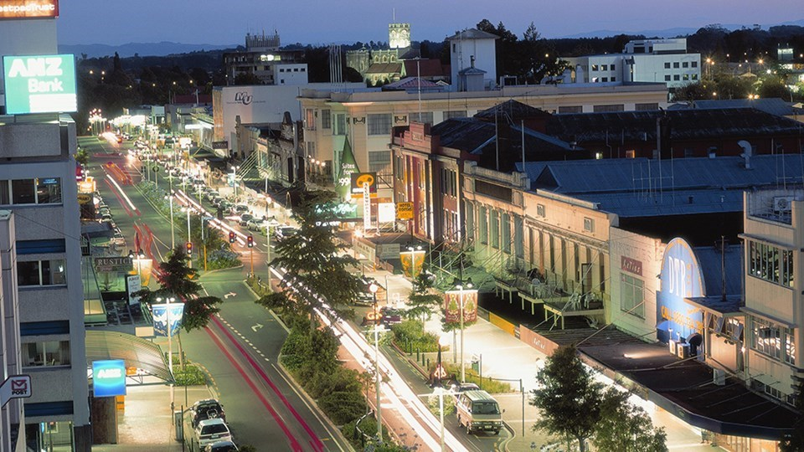

NAtional Flag

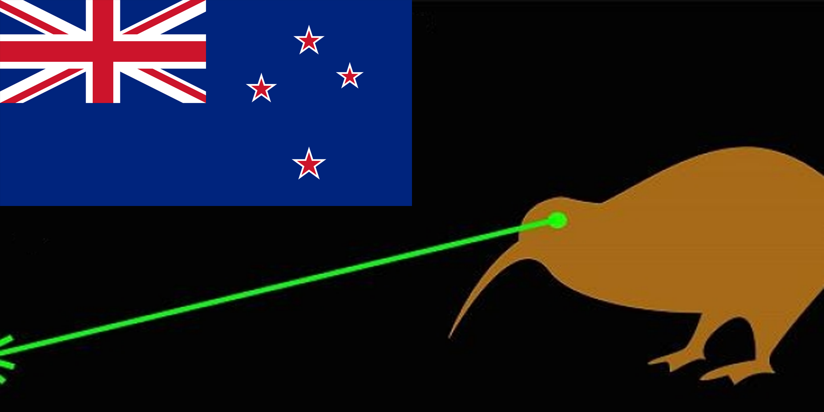

#LazerKiwi

**The perfect representation for our independent nation.**

**We are being true to our roots by honouring our old New Zealand Flag whilst embracing the future with the Lazer Kiwi. We thank James Gray for this marvelous creation**

The hexit team

meet our members!

**Clayton Shashank Gabi Gen**

**\*Special Mention\***

**Barbara Chris Keshav Chris**

